**Programming Assignment Unit 4.**

**Part One:**

**For this task, I will first set up the project by ensuring that I have Python installed, of course, and creating a file named calculate_hypotenuse.py. Then I would start building my function. To follow the best practices of incremental development, I will follow the following steps to build my function:**

***Code 1:***

**def calculate_hypotenuse(a, b):**

**return None # Placeholder for the function**

**To test the function I have Just Created, I will pass some sample arguments to it. See example below:**

**Print(calculate_hyptenuse(5, 8))**

**As expected the above should print nothing but the fact that it has run successfully without any errors proves that my function was created successfully.**

**Test1 Output:**

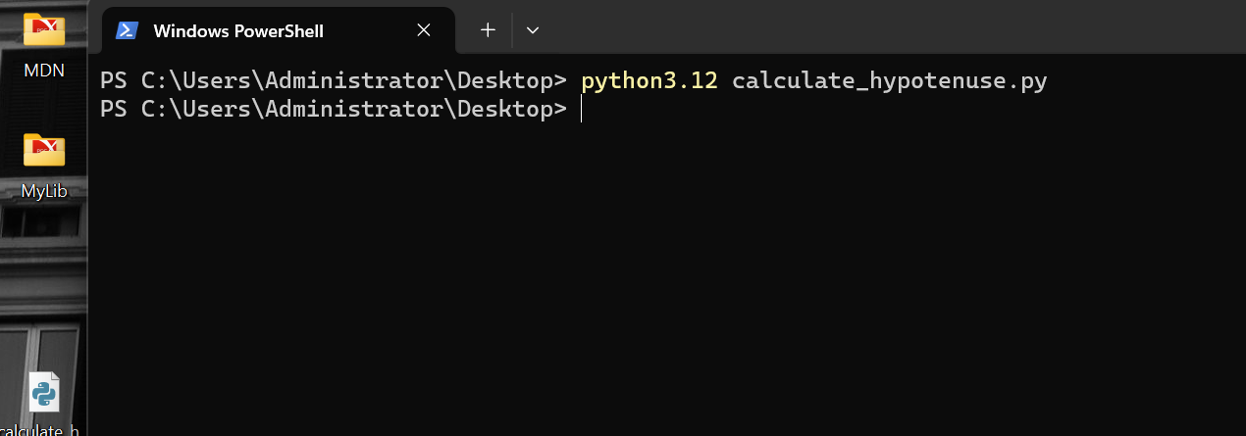

Fig 1.1 Test1.

***Code 2:***

For this next step, I am going to add some code to the function I just defined. It should be able to calculate the square of the first argument in my function which is a after which it should assign it to a variable.

def calculate_hypotenuse(a, b):

    a_squared = a ** 2

    return a_squared

# Test:

result = calculate_hypotenuse(5, 8)

print(result)

***Output:***

PS C:\Users\Administrator> & C:/Python312/python.exe c:/Users/Administrator/Desktop/func.py

25

PS C:\Users\Administrator>

The output is as it is expected, and with that, I will go ahead to repeat the process for the second argument.

Code :

def calculate_hypotenuse(a, b):

    b_squared = b ** 2

    return b_squared

# Test:

result = calculate_hypotenuse(5, 8)

print(result)

output:

PS C:\Users\Administrator> & C:/Python312/python.exe c:/Users/Administrator/Desktop/func.py

64

PS C:\Users\Administrator>

**The complete code this far:**

def calculate_hypotenuse(a, b):

    a_squared = a ** 2

    b_squared = b ** 2

    print(a_squared)

    print(b_squared)

# Test:

result = calculate_hypotenuse(5, 8)

print(result)

**output:**

PS C:\Users\Administrator> & C:/Python312/python.exe c:/Users/Administrator/Desktop/func.py

25

64

None

PS C:\Users\Administrator>

Next, I am going to add some code to my function that calculates the sum of the squares of the two arguments and assigns it to a variable. Below is an example:

**Code :**

def calculate_hypotenuse(a, b):

    a_squared = a ** 2

    b_squared = b ** 2

    c_squared = a_squared + b_squared

    return None

**Tests :**

def calculate_hypotenuse(a, b):

    a_squared = a ** 2

    b_squared = b ** 2

    global c_squared

    c_squared = a_squared + b_squared

print(calculate_hypotenuse(5, 8))

print(c_squared)

**Output:**

PS C:\Users\Administrator> & C:/Python312/python.exe c:/Users/Administrator/Desktop/func.py

None

89

PS C:\Users\Administrator>

In the next step, I am going to calculate the square root of the sum that the arguments assign to a variable.

**Code :**

def calculate_hypotenuse(a, b):

    a_squared = a ** 2

    b_squared = b ** 2

    c_squared = a_squared + b_squared

    c = c_squared ** 0.5

    return c

**Tests:**

def calculate_hypotenuse(a, b):

    a_squared = a ** 2

    b_squared = b ** 2

    c_squared = a_squared + b_squared

    c = c_squared ** 0.5

    return c

# Tests - Use the function to calculate and print the hypotenuse

result = calculate_hypotenuse(5, 8)

print(result)

**output:**

PS C:\Users\Administrator> & C:/Python312/python.exe c:/Users/Administrator/Desktop/func.py

9.433981132056603

PS C:\Users\Administrator>

**Part 2:**

For the second part of this assignment which is to build my portfolio as a Software Developer, I am going to begin by setting up a repository on GitHub (which is a version control that developers use to manage their projects) for the project.

This is the [link](https://github.com/codelord-evans/UoPeople_File-Organizer.git) to the project.